**EXPERIMENT-1**

**Aim:** To study the basic commands of Arduino

**Apparatus Used:** Arduino Bord

**Software Used:** Arduino 1.8.19 (https://www.arduino.cc)

**Theory:** Arduino UNO is a microcontroller board based on the **ATmega328P**. It has 14 digital input/output pins (of which 6 can be used as PWM outputs), 6 analog inputs, a 16 MHz ceramic resonator, a USB connection, a power jack, an ICSP header and a reset button. It contains everything needed to support the microcontroller; simply connect it to a computer with a USB cable or power it with a AC-to-DC adapter or battery to get started.

Differences with other boards

The Uno differs from all preceding boards in that it does not use the FTDI USB-to-serial driver chip. Instead, it features the Atmega16U2 (Atmega8U2 up to version R2) programmed as a USB-to-serial converter.

Power

The Arduino/Genuino Uno board can be powered via the USB connection or with an external power supply. The power source is selected automatically.

External (non-USB) power can come either from an AC-to-DC adapter (wall-wart) or battery. The adapter can be connected by plugging a 2.1mm center-positive plug into the board's power jack. Leads from a battery can be inserted in the GND and Vin pin headers of the POWER connector.

The board can operate on an external supply from 6 to 20 volts. If supplied with less than 7V, however, the 5V pin may supply less than five volts and the board may become unstable. If using more than 12V, the voltage regulator may overheat and damage the board. The recommended range is 7 to 12 volts.

The power pins are as follows:

* Vin. The input voltage to the Arduino/Genuino board when it's using an external power source (as opposed to 5 volts from the USB connection or other regulated power source). You can supply voltage through this pin, or, if supplying voltage via the power jack, access it through this pin.
* 5V.This pin outputs a regulated 5V from the regulator on the board. The board can be supplied with power either from the DC power jack (7 - 12V), the USB connector (5V), or the VIN pin of the board (7-12V). Supplying voltage via the 5V or 3.3V pins bypasses the regulator, and can damage your board. We don't advise it.
* 3V3. A 3.3 volt supply generated by the on-board regulator. Maximum current draw is 50 mA.
* GND. Ground pins.
* IOREF. This pin on the Arduino/Genuino board provides the voltage reference with which the microcontroller operates. A properly configured shield can read the IOREF pin voltage and select the appropriate power source or enable voltage translators on the outputs to work with the 5V or 3.3V.

Memory

The ATmega328 has 32 KB (with 0.5 KB occupied by the bootloader). It also has 2 KB of SRAM and 1 KB of EEPROM (which can be read and written with the [EEPROM library](https://www.arduino.cc/en/Reference/EEPROM)).

Input and Output

See the mapping between Arduino pins and ATmega328P ports. The mapping for the Atmega8, 168, and 328 is identical.

Each of the 14 digital pins on the Uno can be used as an input or output, using [pinMode()](https://www.arduino.cc/en/Reference/PinMode), [digitalWrite()](https://www.arduino.cc/en/Reference/DigitalWrite), and [digitalRead()](https://www.arduino.cc/en/Reference/DigitalRead) functions. They operate at 5 volts. Each pin can provide or receive 20 mA as recommended operating condition and has an internal pull-up resistor (disconnected by default) of 20-50k ohm. A maximum of 40mA is the value that must not be exceeded on any I/O pin to avoid permanent damage to the microcontroller.

In addition, some pins have specialized functions:

* Serial: 0 (RX) and 1 (TX). Used to receive (RX) and transmit (TX) TTL serial data. These pins are connected to the corresponding pins of the ATmega8U2 USB-to-TTL Serial chip.
* External Interrupts: 2 and 3. These pins can be configured to trigger an interrupt on a low value, a rising or falling edge, or a change in value. See the attachInterrupt() function for details.
* PWM: 3, 5, 6, 9, 10, and 11. Provide 8-bit PWM output with the analogWrite() function.
* SPI: 10 (SS), 11 (MOSI), 12 (MISO), 13 (SCK). These pins support SPI communication using the SPI library.
* LED: 13. There is a built-in LED driven by digital pin 13. When the pin is HIGH value, the LED is on, when the pin is LOW, it's off.
* TWI: A4 or SDA pin and A5 or SCL pin. Support TWI communication using the Wire library.

The Uno has 6 analog inputs, labeled A0 through A5, each of which provide 10 bits of resolution (i.e. 1024 different values). By default they measure from ground to 5 volts, though is it possible to change the upper end of their range using the AREF pin and the analogReference() function.  
There are a couple of other pins on the board:

* AREF. Reference voltage for the analog inputs. Used with analogReference().
* Reset. Bring this line LOW to reset the microcontroller. Typically used to add a reset button to shields which block the one on the board.

Specification of Arduino Uno Board

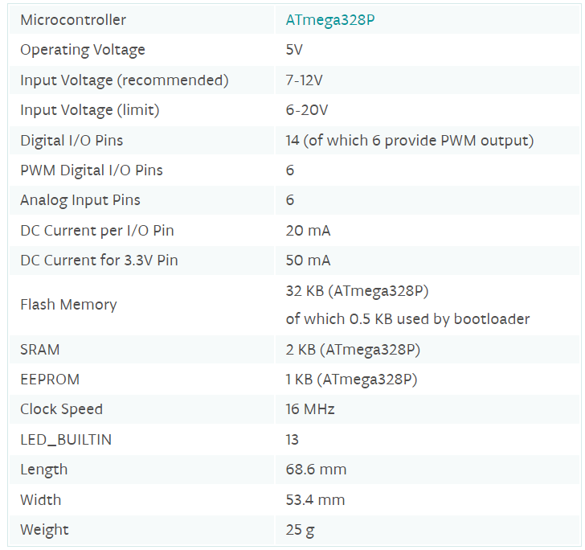

**BASIC COMMANDS/ FUNCTIONS FOR ARDUINO PROGRAMMING**

1. setup(): The setup() function is called when a sketch starts. Use it to initialize variables, pin modes, start using libraries, etc. The setup() function will only run once, after each powerup or reset of the Arduino board.
2. loop(): After creating a [setup()](https://www.arduino.cc/reference/en/language/structure/sketch/setup) function, which initializes and sets the initial values, the loop() function does precisely what its name suggests, and loops consecutively, allowing your program to change and respond. Use it to actively control the Arduino board.

# digitalRead(): Reads the value from a specified digital pin, either HIGH or LOW.

# digitalWrite(): Write a HIGH or a LOW value to a digital pin.

# Syntax: digitalWrite (pin,HIGH), digitalWrite (pin, LOW)

1. pinMode(): Configures the specified pin to behave either as an input or an output.

Syntax: pinMode(pin, mode)

1. analogRead(): Reads the value from the specified analog pin. Syntax : analogRead(pin)

# analogReference(): Configures the reference voltage used for analog input (i.e. the value used as the top of the input range). Syntax: analogReference(type)

# analogWrite() : Writes an analog value ([PWM wave](http://arduino.cc/en/Tutorial/PWM)) to a pin. Can be used to light a LED at varying brightnesses or drive a motor at various speeds. After a call to analogWrite(), the pin will generate a steady rectangular wave of the specified duty cycle until the next call to analogWrite() (or a call to digitalRead() or digitalWrite()) on the same pin. Syntax: analogWrite(pin, value)

# delay(): Pauses the program for the amount of time (in milliseconds) specified as parameter. (There are 1000 milliseconds in a second.) Syntax: delay(ms)